Hello. My name is Kodie Barrett, which admittedly is not a very convincing name for my rather asian appearance, but I will explain it in a bit. I am an exchange student from the University of Hong Kong majoring in Sociology/Anthropology with a minor in politics. In Hong Kong I am a real estate agent, barista and model to fund my education. I am only in PGS for 1 semester and plan on completing a majority of my minor credits while I am here. I was born in Hong Kong to Vietnamese parents and given up for adoption, where I was then adopted by a loving Australian family, hence the very white name. I have lived in Hong Kong my whole life. The juxtaposition of nature and the many steel skyscrapers that make up our iconic skyline has always been one of the most unique feelings. The wealth disparity between the wealthy and the poor living and eating within close proximity of one another in such a small city has been one of the driving factors in my interest in sociology, anthropology and politics. My current interests include how urbanisation has changed social dynamics, such as how the shift to living in apartments has altered traditional community dynamics and social cohesion through how their design has affected social interactions and the idea of the “neighbour”. WIth Hong Kong being a former colony of the British Empire, I am also very interested in dismantling harmful eurocentric notions brought about by the likes of colonialism and the media. Having all this in mind, PGS was an obvious choice when I was selecting what course to study in Chula. The different nature of each class was appealing to me, as it seemed to be a wide array of different fields, providing a cohesive learning experience without spreading itself too thin. 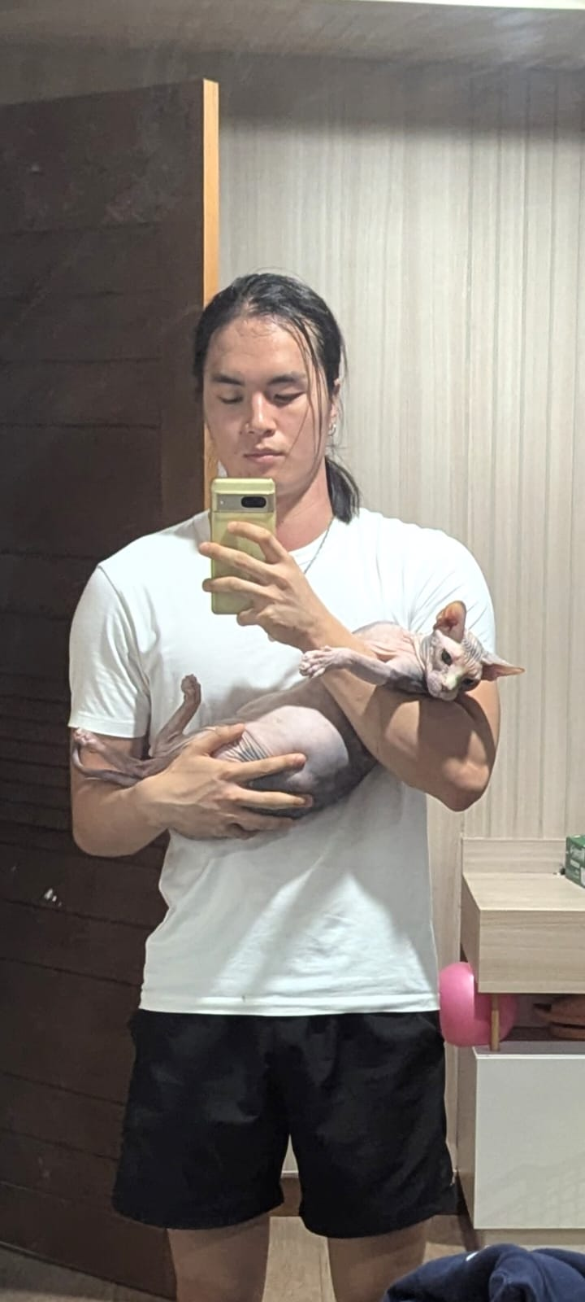

In terms of my future aspirations, I want to travel the world working odd-jobs as my mum did when she was young – hopefully gaining some interesting lore for my kids along the way– and then ideally become an international school IB teacher and provide young people with a valuable education like the one I was very privileged to receive.